(1) To Print the Factorial of a Number

CODE :

<!DOCTYPE html>

<html lang="en">

<head>

<meta charset="UTF-8">

<meta http-equiv="X-UA-Compatible" content="IE=edge">

<meta name="viewport" content="width=device-width, initial-scale=1.0">

<meta name="Description" content="JavaScript - Factorial">

<title>JavaScript Factorial</title>

</head>

<body>

<script>

// To Print the Factorial of a Number

const number = BigInt(prompt('Enter a positive integer: '));

if (number < 0) {

console.log('Error! Factorial for negative number does not exist.');

}

else if (number === 0) {

console.log(`The factorial of ${number} is 1.`);

}

else {

let fact = 1;

for (i = 1; i <= number; i++) {

fact *= i;

}

console.log(`The factorial of ${number} is ${fact}.`);

}

</script>

</body>

</html>

OUTPUT:

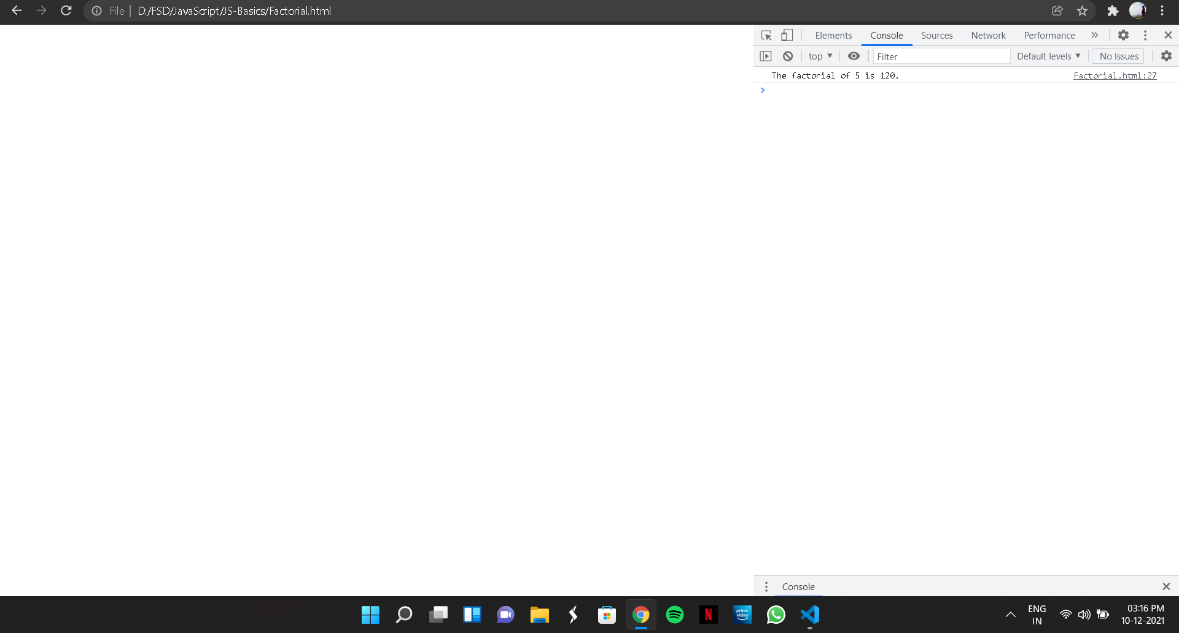

(2) To Print the Fibonacci Series

CODE:

<!DOCTYPE html>

<html lang="en">

<head>

<meta charset="UTF-8">

<meta http-equiv="X-UA-Compatible" content="IE=edge">

<meta name="viewport" content="width=device-width, initial-scale=1.0">

<meta name="Description" content="JavaScript - Fibonacci Series">

<title>JavaScript - Fibonacci Series</title>

</head>

<body>

<script>

// To Print the Fibonacci Series

const number = BigInt(prompt('Enter a positive number: '));

let n1 = 0, n2 = 1, nextTerm;

console.log('Fibonacci Series:');

console.log(n1);

console.log(n2);

nextTerm = n1 + n2;

while (nextTerm <= number) {

console.log(nextTerm);

n1 = n2;

n2 = nextTerm;

nextTerm = n1 + n2;

}

</script>

</body>

</html>

OUTPUT:

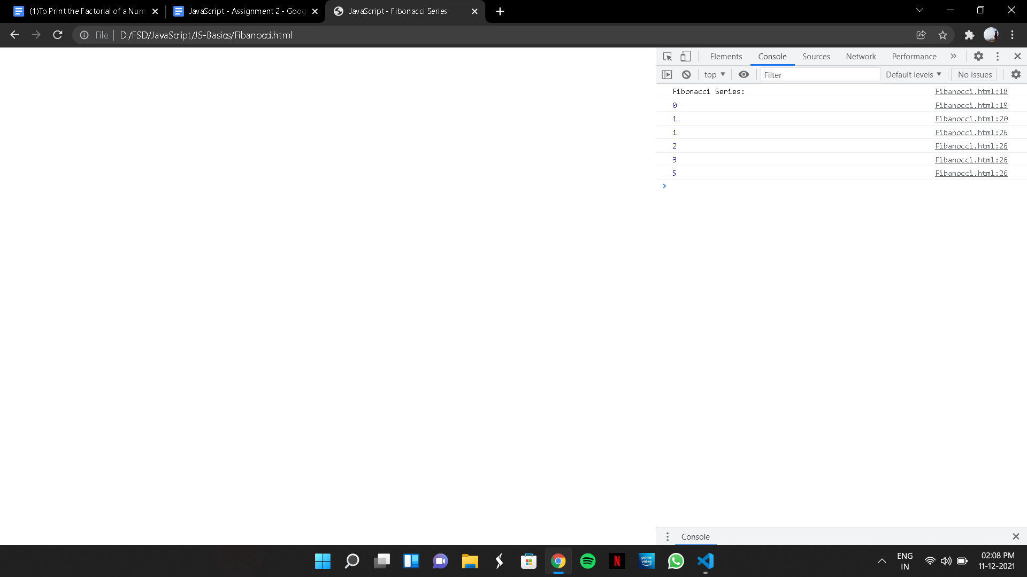

(3) To find whether a Number is Armstrong or not

CODE :

<!DOCTYPE html>

<html lang="en">

<head>

<meta charset="UTF-8">

<meta http-equiv="X-UA-Compatible" content="IE=edge">

<meta name="viewport" content="width=device-width, initial-scale=1.0">

<meta name="Description" content="JavaScript - Armstrong Number">

<title>JavaScript - Armstrong Number</title>

</head>

<body>

<script>

// To find whether a Number is Armstrong or not

const number = prompt("Enter a positive integer");

const numberOfDigits = number.length;

let sum = 0;

let temp = number;

while (temp > 0) {

let remainder = temp % 10;

sum += remainder ** numberOfDigits;

temp = parseInt(temp / 10);

}

if (sum == number) {

console.log(`${number} is an Armstrong number`);

}

else {

console.log(`${number} is not an Armstrong number.`);

}

</script>

</body>

</html>

OUTPUT:

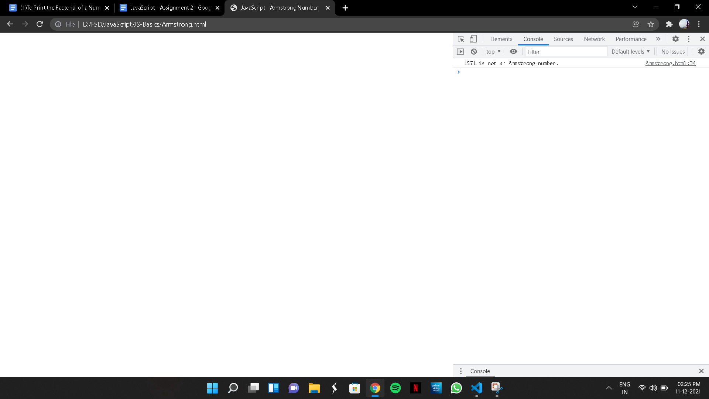

(4) To Print Reverse of a Number

CODE:

<!DOCTYPE html>

<html lang="en">

<head>

<meta charset="UTF-8">

<meta http-equiv="X-UA-Compatible" content="IE=edge">

<meta name="viewport" content="width=device-width, initial-scale=1.0">

<meta name="Description" content="JavaScript - Reverse a Number">

<title>JavaScript - Reverse a Number</title>

</head>

<body>

<script>

// To Print Reverse of a Number

let rev = 0;

let num = 123456;

rev = Number(String(num).split('').reverse().join(''));

console.log("Reverse number : "+rev);

</script>

</body>

</html>

OUTPUT:



(5)To check whether a Number is Prime or Not

CODE:

<!DOCTYPE html>

<html lang="en">

<head>

<meta charset="UTF-8">

<meta http-equiv="X-UA-Compatible" content="IE=edge">

<meta name="viewport" content="width=device-width, initial-scale=1.0">

<meta name="Description" content="JavaScript - Prime Number">

<title>JavaScript - Prime Number</title>

</head>

<body>

<script>

// To check whether a Number is Prime or Not

const number = parseInt(prompt("Enter a positive number: "));

let isPrime = true;

if (number === 1) {

console.log("1 is neither prime nor composite number.");

}

else if (number > 1) {

for (let i = 2; i < number; i++) {

if (number % i == 0) {

isPrime = false;

break;

}

}

if (isPrime) {

console.log(`${number} is a prime number`);

} else {

console.log(`${number} is not a prime number`);

}

}

</script>

</body>

</html>

OUTPUT:

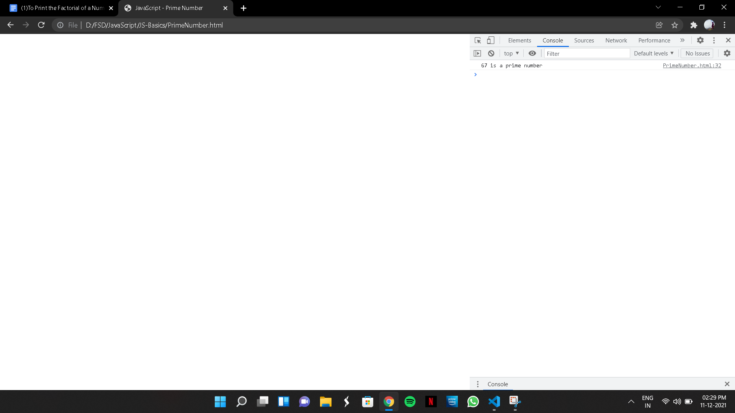

(6)To find whether an year is a Leap Year or not

CODE:

<!DOCTYPE html>

<html lang="en">

<head>

<meta charset="UTF-8">

<meta http-equiv="X-UA-Compatible" content="IE=edge">

<meta name="viewport" content="width=device-width, initial-scale=1.0">

<meta name="Description" content="JavaScript - LeapYear">

<title>JavaScript - LeapYear</title>

</head>

<body>

<script>

// To find whether an year is a Leap Year or not

function checkLeapYear(year) {

if ((0 == year % 4) && (0 != year % 100) || (0 == year % 400)) {

console.log(year + ' is a leap year');

}

else {

console.log(year + ' is not a leap year');

}

}

const year = prompt('Enter a year:');

checkLeapYear(year);

</script>

</body>

</html>

OUTPUT:

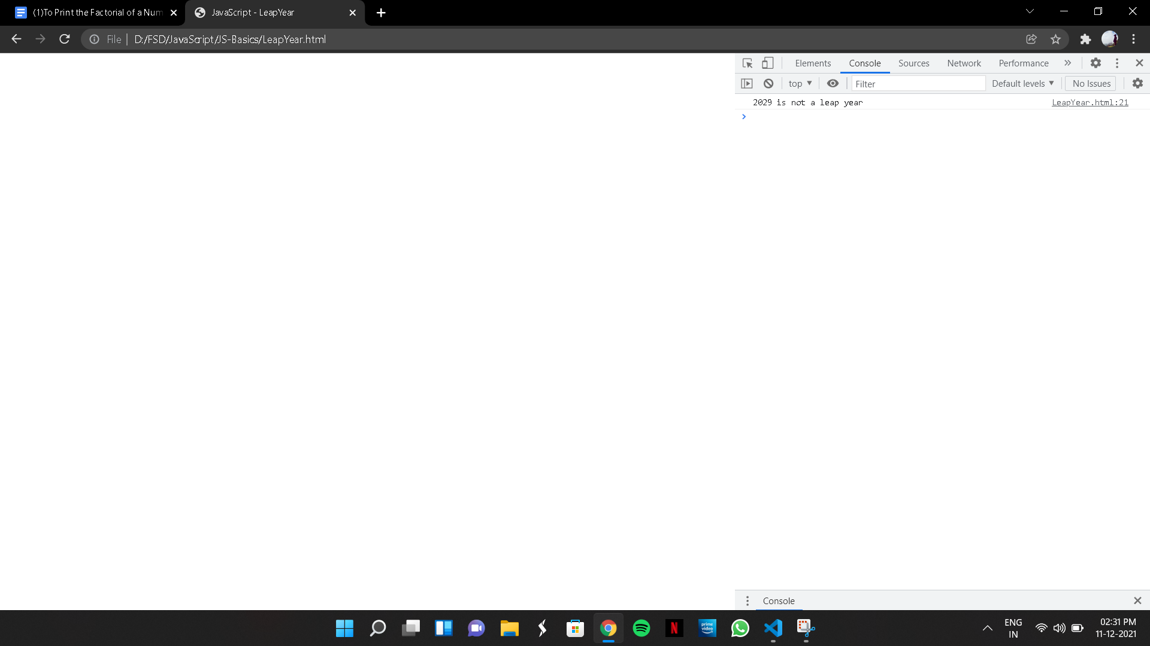

(7) To Print Downward Triangle Star Format

CODE:

<!DOCTYPE html>

<html lang="en">

<head>

<meta charset="UTF-8">

<meta http-equiv="X-UA-Compatible" content="IE=edge">

<meta name="viewport" content="width=device-width, initial-scale=1.0">

<meta name="Description" content="JavaScript - Downward Star Pattern">

<title>JavaScript - Downward Star Pattern</title>

</head>

<body>

<script>

// To Print Downward Triangle Star Format

let n = 5;

let string = "";

for (let i = 0; i < n; i++) {

for (let j = 0; j < n - i; j++) {

string += "*";

}

string += "\n";

}

console.log(string);

</script>

</body>

</html>

OUTPUT:

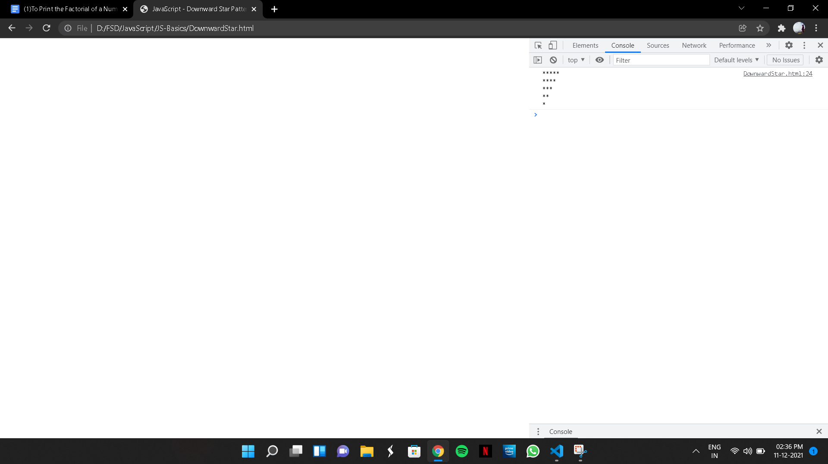

(8)To Print a pattern of Reverse Number Triangle

CODE:

<!DOCTYPE html>

<html lang="en">

<head>

<meta charset="UTF-8">

<meta http-equiv="X-UA-Compatible" content="IE=edge">

<meta name="viewport" content="width=device-width, initial-scale=1.0">

<meta name="Description" content="JavaScript - Reverse Number Triangle">

<title>Reverse Number Triangle</title>

</head>

<body>

<script>

// To Print a pattern of Reverse Number Triangle

let n = 5;

let string = "";

for (let i = 1; i <= n; i++) {

for (let j = 1; j <= n - i + 1; j++) {

string += j;

}

string += "\n";

}

console.log(string);

</script>

</body>

</html>

OUTPUT:

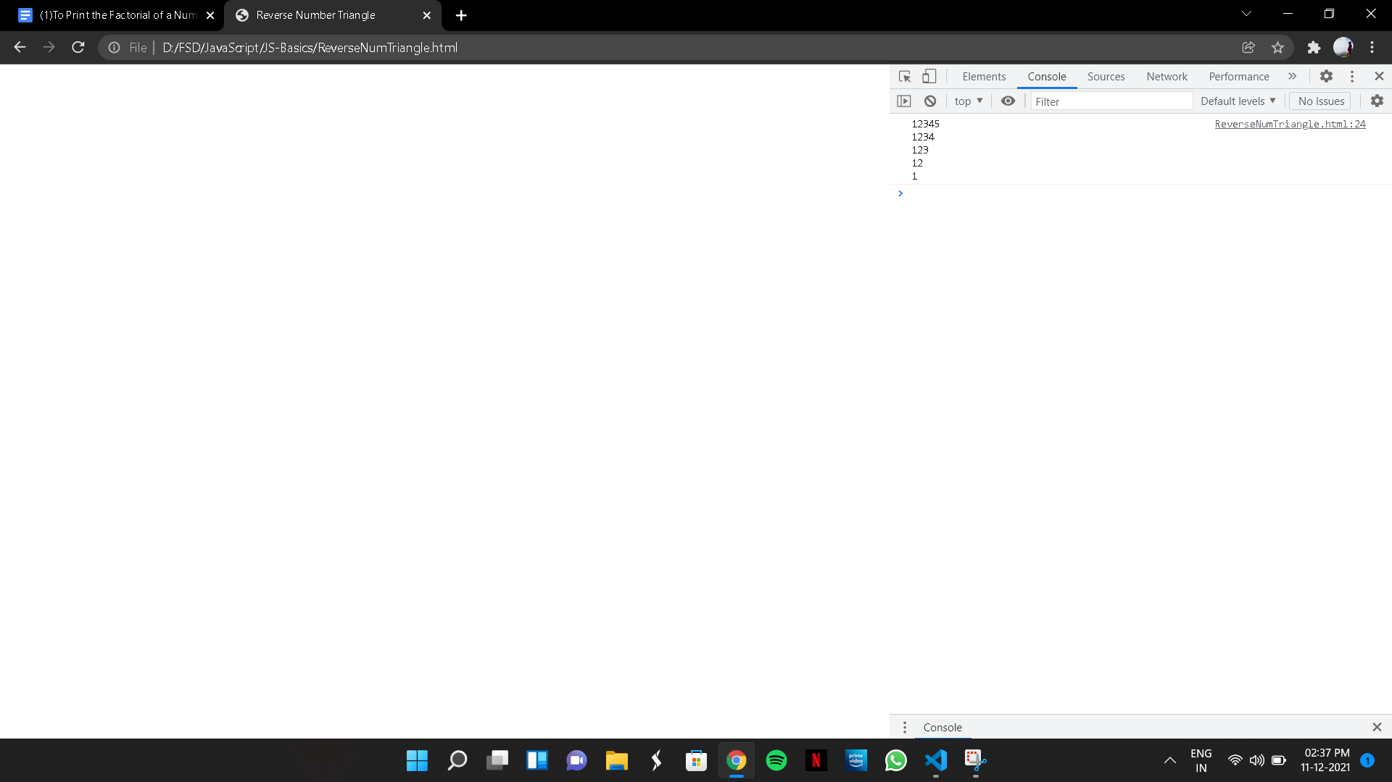

(9a) To Print a Left Star Triangle Pattern

CODE:

<!DOCTYPE html>

<html lang="en">

<head>

<meta charset="UTF-8">

<meta http-equiv="X-UA-Compatible" content="IE=edge">

<meta name="viewport" content="width=device-width, initial-scale=1.0">

<meta name="Description" content="JavaScript - Left Star Triangle">

<title>JavaScript - Left Star Triangle</title>

</head>

<body>

<script>

// To Print a Left Star Triangle Pattern

let n = 5;

let string = "";

for (let i = 1; i <= n; i++) {

for (let j = 0; j < i; j++) {

string += "*";

}

string += "\n";

}

console.log(string);

</script>

</body>

</html>

OUTPUT:

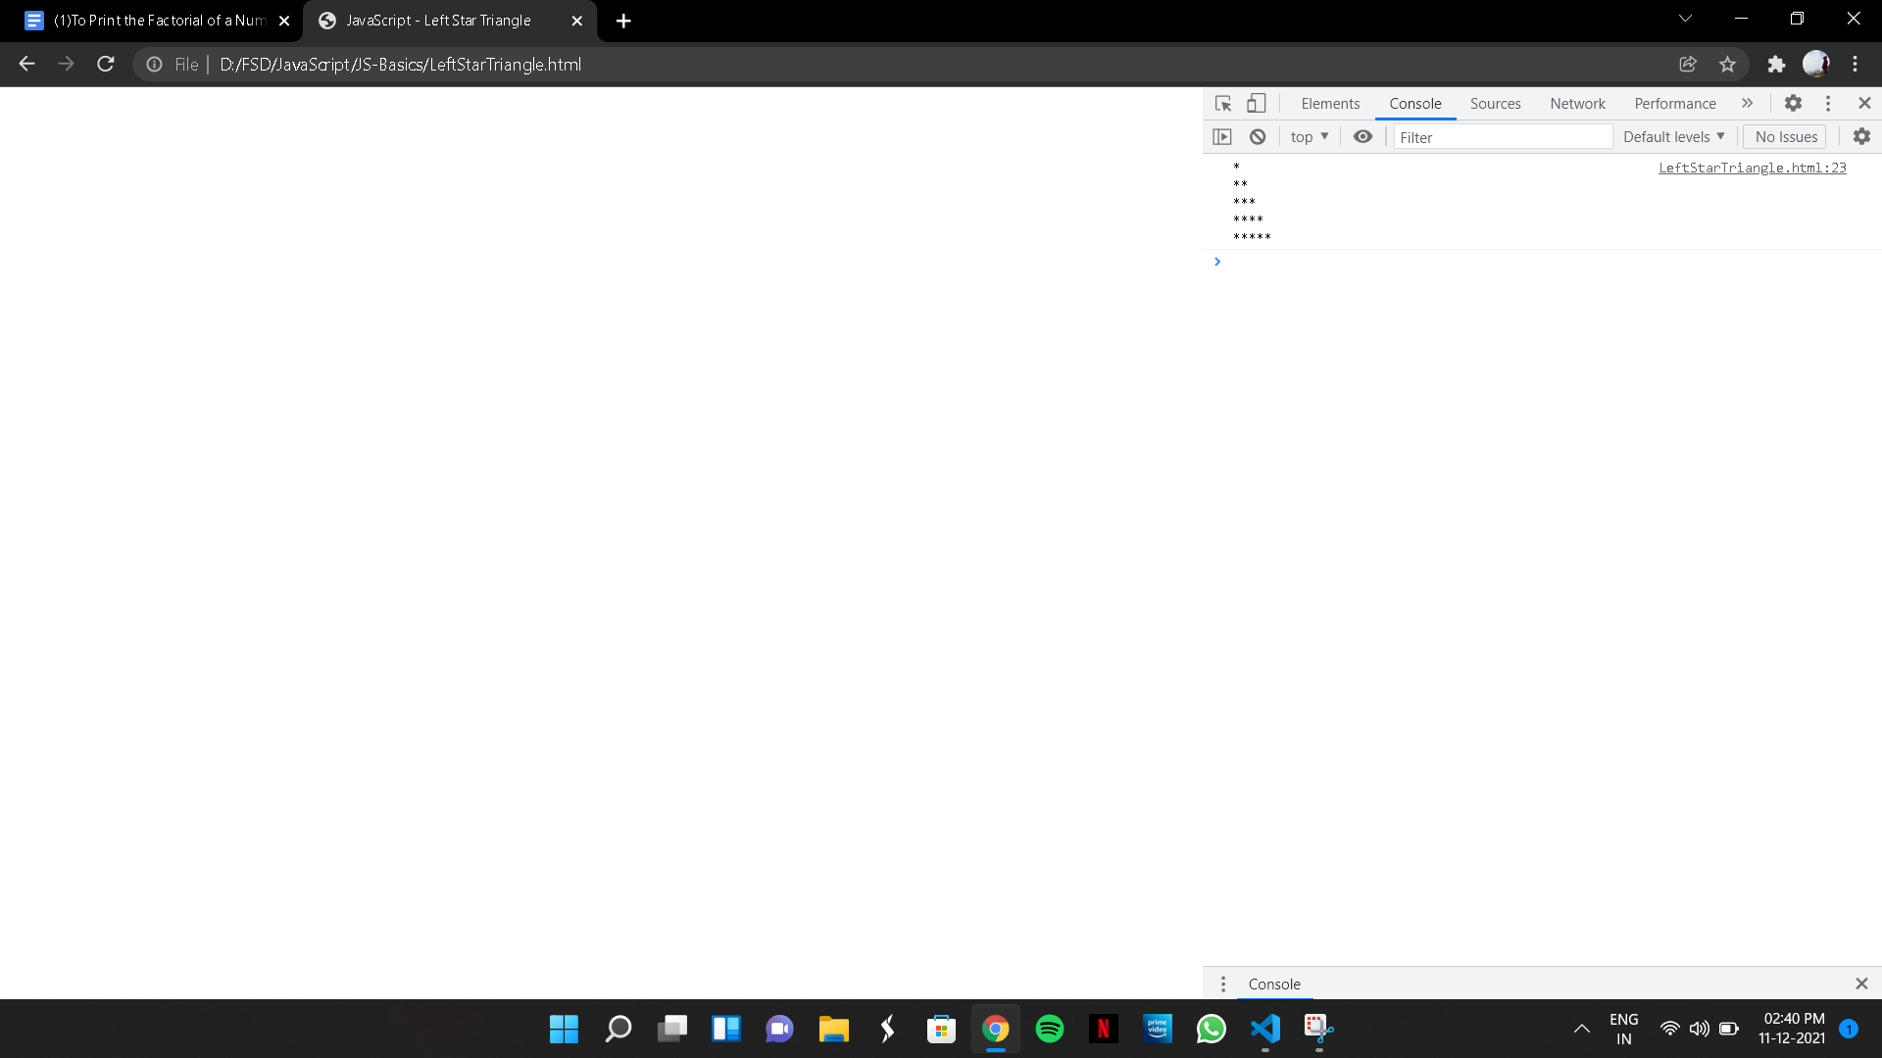

(9b)

CODE:

<!DOCTYPE html>

<html lang="en">

<head>

<meta charset="UTF-8">

<meta http-equiv="X-UA-Compatible" content="IE=edge">

<meta name="viewport" content="width=device-width, initial-scale=1.0">

<meta name="Description" content="JavaScript - Triangle Number Pattern">

<title>Triangle Number Pattern</title>

</head>

<body>

<script>

// To Print a Triangle Number Pattern

let n = 5;

let string = "";

for (let i = 1; i <= n; i++) {

for (let j = 1; j <= i; j++) {

string += j;

}

string += "\n";

}

console.log(string);

</script>

</body>

</html>

OUTPUT:

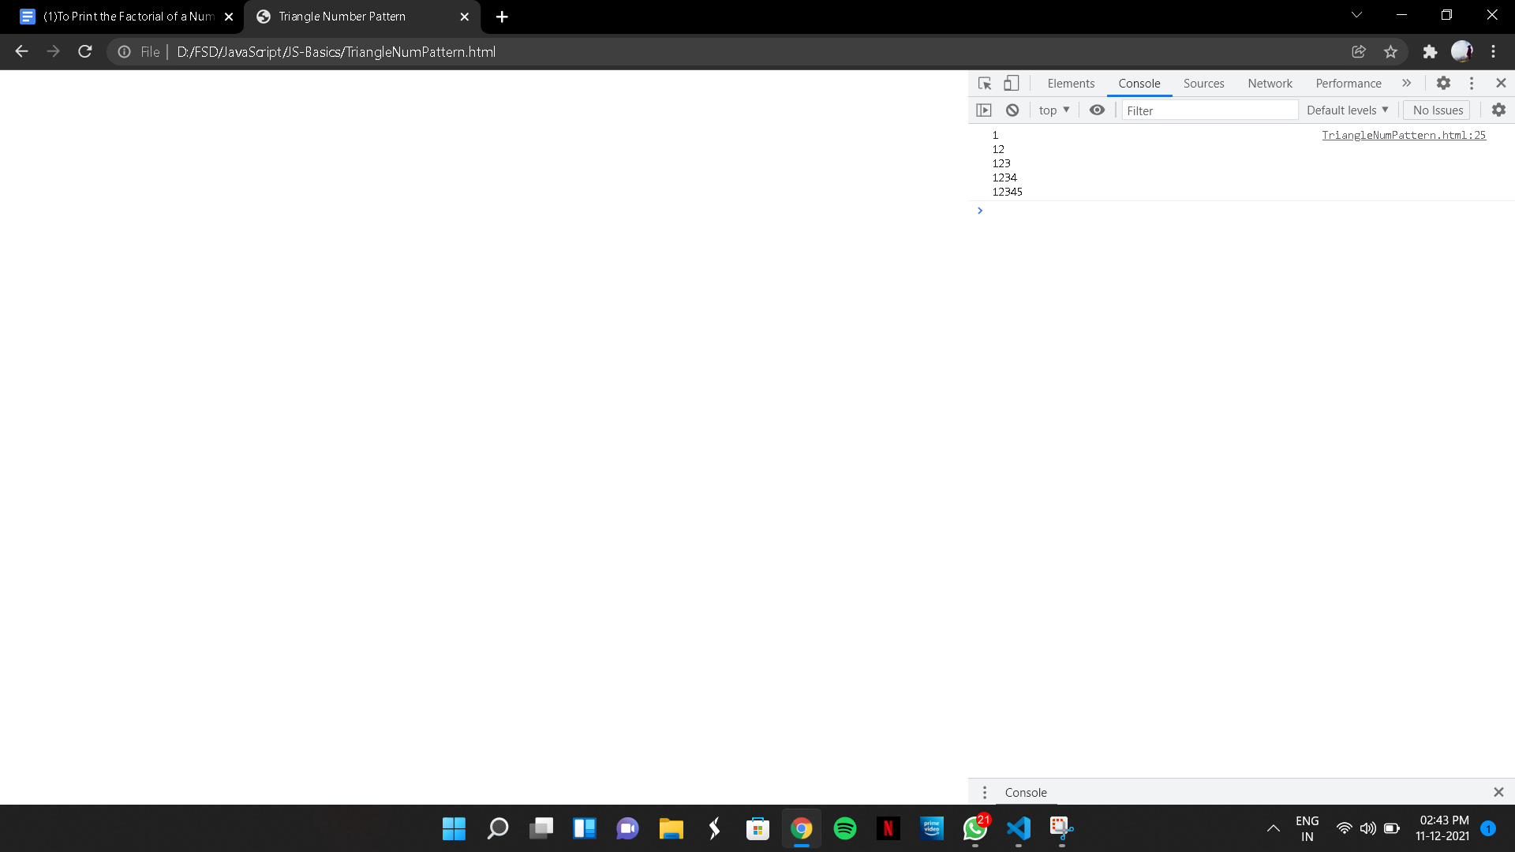

(10) To print the Factor of a Number

CODE:

<!DOCTYPE html>

<html lang="en">

<head>

<meta charset="UTF-8">

<meta http-equiv="X-UA-Compatible" content="IE=edge">

<meta name="viewport" content="width=device-width, initial-scale=1.0">

<title>Document</title>

</head>

<body>

<script>

function print_factors(num) {

for (let i = 1; i <= num; i++) {

if (num % i == 0) {

console.log(i);

}

}

}

num = prompt("Enter the Number");

console.log(`Factors of ${num}`);

print_factors(num)

</script>

</body>

</html>

OUTPUT:

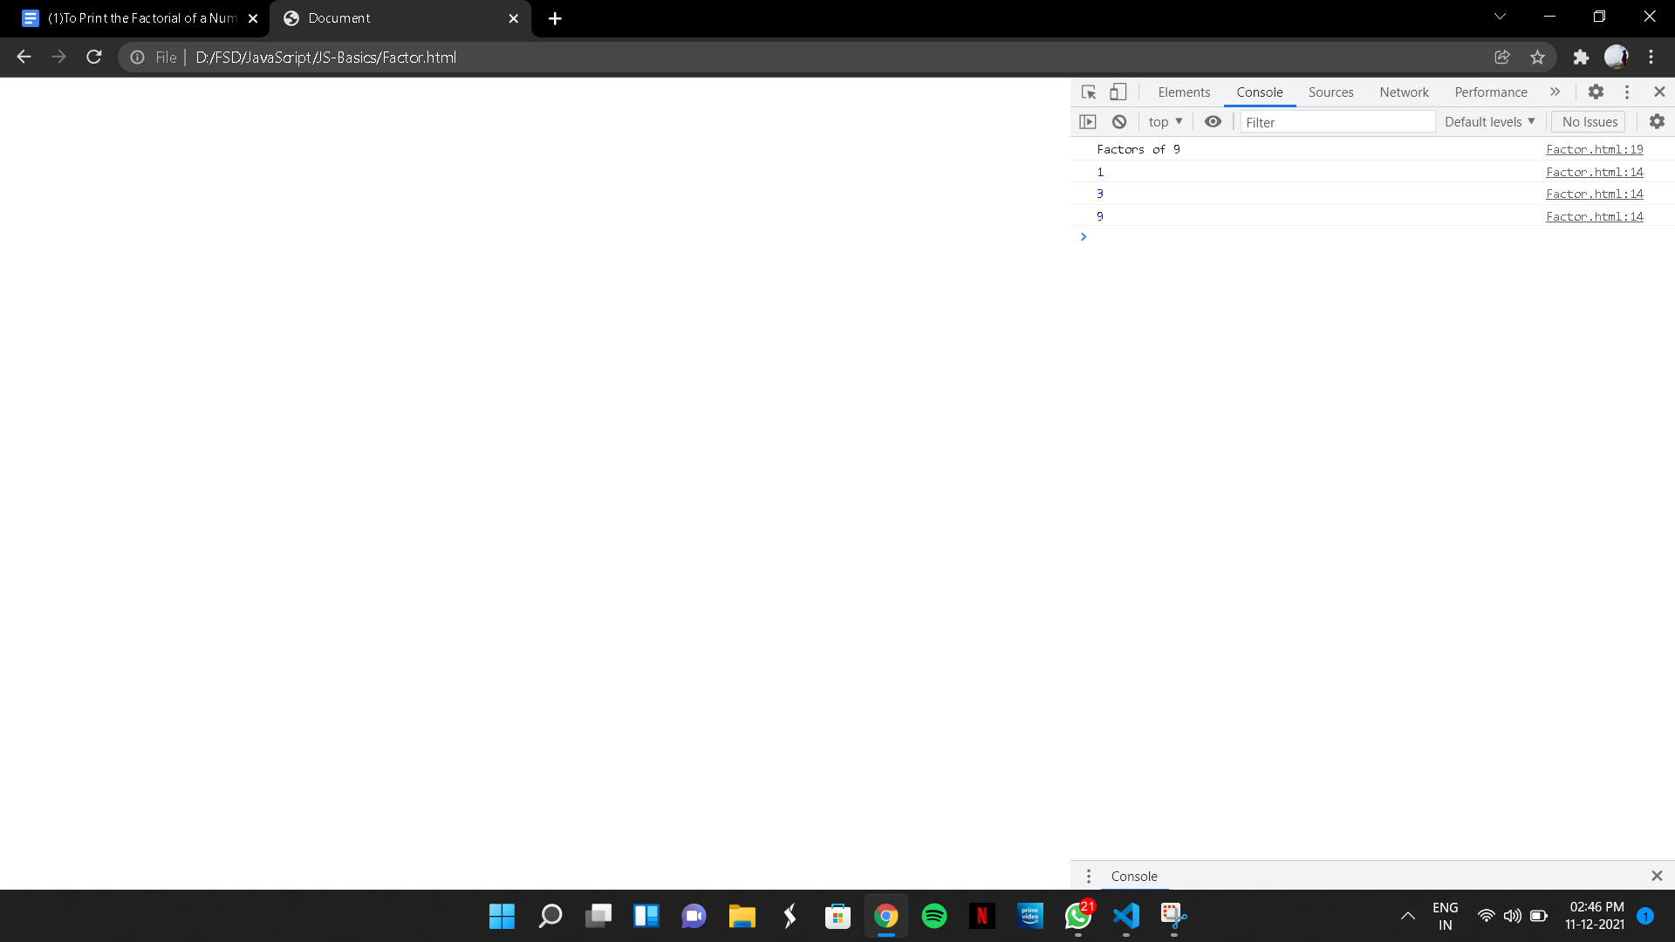

(11) To find the Table of a number

CODE:

<!DOCTYPE html>

<html lang="en">

<head>

<meta charset="UTF-8">

<meta http-equiv="X-UA-Compatible" content="IE=edge">

<meta name="viewport" content="width=device-width, initial-scale=1.0">

<title>Document</title>

</head>

<body>

<script>

// To find the Table of a number

let num = prompt("Enter the Number to Find their tables");

function tables(num) {

for (let count=1; count<=10; count++) {

console.log(`${num}x${count}=${num*count}`);

}

}

tables(num);

</script>

</body>

</html>

OUTPUT:

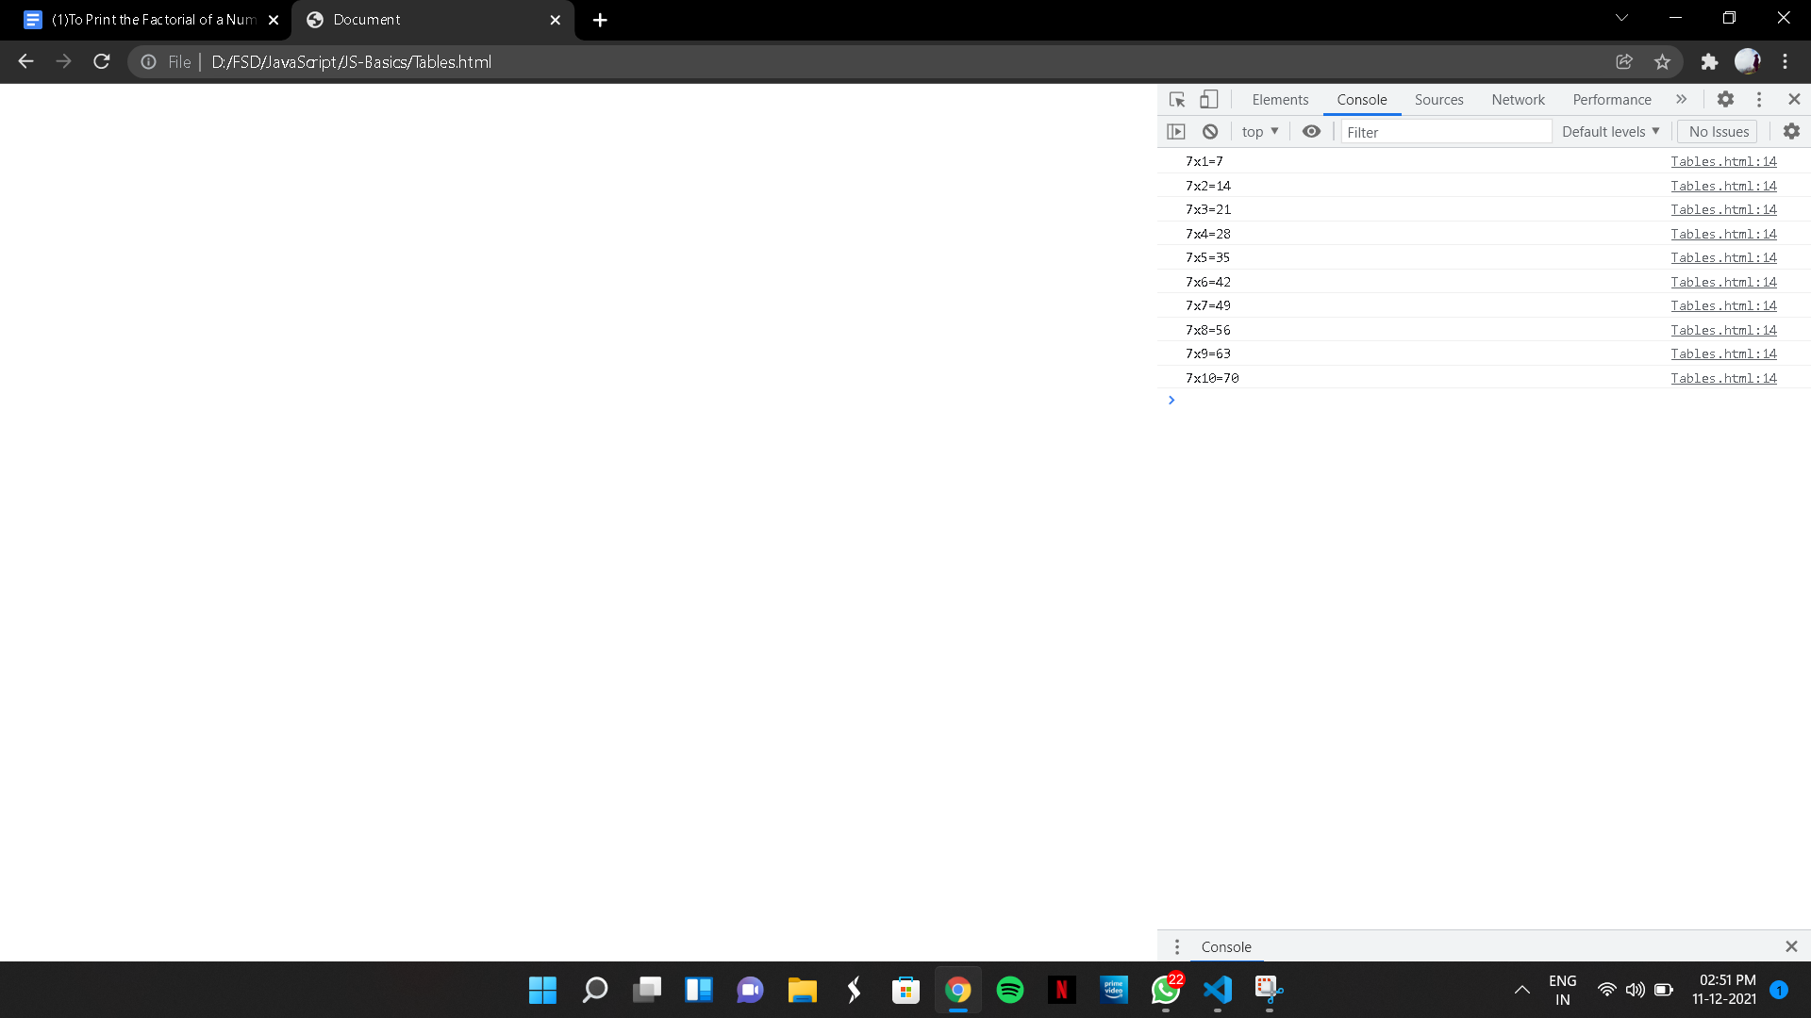

(12)To Swap two Numbers

CODE:

<!DOCTYPE html>

<html lang="en">

<head>

<meta charset="UTF-8">

<meta http-equiv="X-UA-Compatible" content="IE=edge">

<meta name="viewport" content="width=device-width, initial-scale=1.0">

<title>Document</title>

</head>

<body>

<script>

//To Swap two Numbers

let a = prompt("Enter the First Number");

let b = prompt("Enter the Second Number");

let temp;

function swap(a, b) {

temp = a;

a = b;

b = temp;

console.log(`After Swapping: a=${a} b=${b}`)

}

console.log(`Before Swapping: a=${a} b=${b}`)

swap(a, b);

</script>

</body>

</html>

OUTPUT:

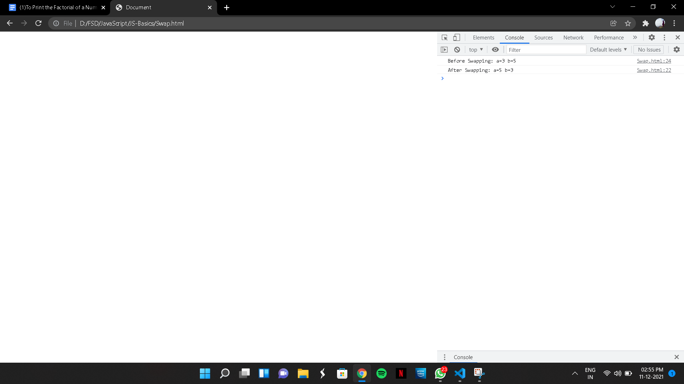

(13) To Swap two numbers without using third variable

CODE:

<!DOCTYPE html>

<html lang="en">

<head>

<meta charset="UTF-8">

<meta http-equiv="X-UA-Compatible" content="IE=edge">

<meta name="viewport" content="width=device-width, initial-scale=1.0">

<meta name="Description" content="JavaScript - Swap Without Using Third Variable">

<title>JavaScript - Swap Without Using Third Variable</title>

</head>

<body>

<script>

//To Swap two numbers without using third variable

let a = 10, b = 20;

console.log(a, b);

a = a + b;

b = a - b;

a = a - b;

console.log(a,b);

</script>

</body>

</html>

OUTPUT:

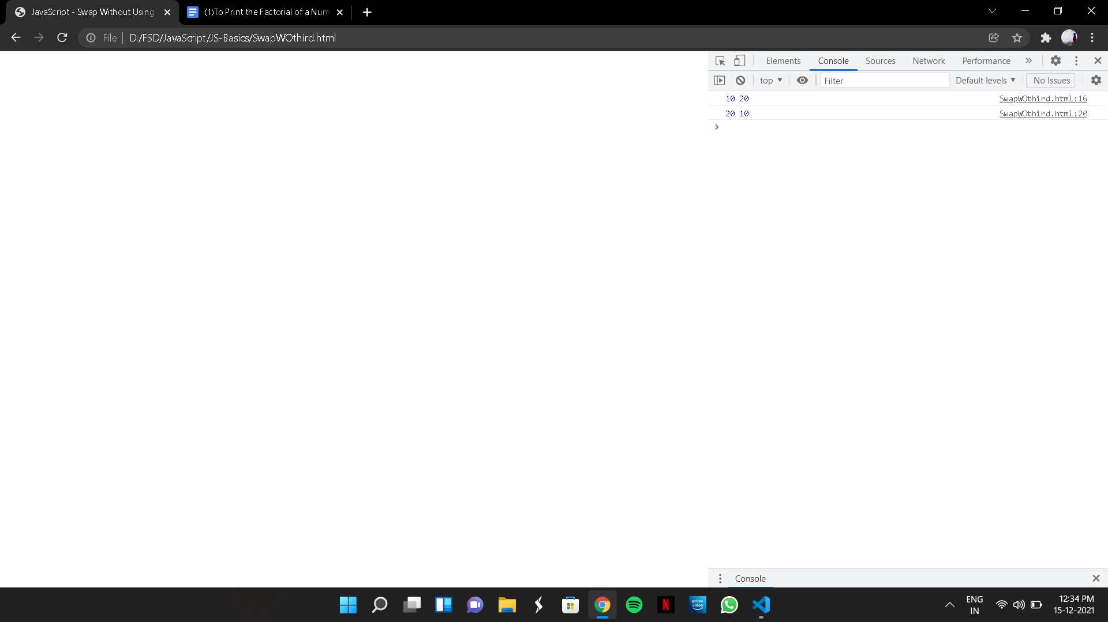

(14) To Print Rectangular Star Pattern

CODE:

<!DOCTYPE html>

<html lang="en">

<head>

<meta charset="UTF-8">

<meta http-equiv="X-UA-Compatible" content="IE=edge">

<meta name="viewport" content="width=device-width, initial-scale=1.0">

<meta name="Description" content="JavaScript - Rectangular Star Pattern">

<title>JavaScript - Rectangular Star Pattern</title>

</head>

<body>

<script>

// To Print Rectangular Star Pattern

let n = 5;

let star="";

for( let i=0; i<n; i++){

for( let j=0; j<n; j++){

star +="*";

}

star +="\n"

}

console.log(star);

</script>

</body>

</html>

OUTPUT:

